**CHAPTER 1**

**1.0. INTRODUCTION.**

In recent years, research has shown that Nigeria's population continues to grow at an unprecedented rate to about 2.4% annually. Most people live in slums and shantytowns, putting more pressure on the informal sector. Most workers lack educational qualifications and are forced to be in an informal sector for financial survival. This sector has no fixed wage structure; thus, most workers want to avoid permanent employment in this service sector (Ogunrinde et al.2023).

According to a review done by Irunga in 2015, the author opined that the informal sector is growing as a result of rising rural-to-urban migration and the formal sector's failure to absorb a large number of job seekers in the country, resulting in the creation of new work opportunities in the informal sector, such as handyman service occupations.

**1.1. BACKGROUND STUDY.**

With the growing population of Nigeria, it is unavoidable for the demand of handy man to rise and due to the failure of the formal sector to absorb a larger number of job seekers , the creation of new jobs in the informal sector such as handy men is expected.

A handyman, also known as a fixer, handymen or handy worker, maintenance worker, repair worker, or repair technician, is a person skilled at a wide range of repairs, typically for keeping buildings, shops or equipment around the home in good repair. (ResumeCat, 2022).

In most African countries, handymen services are part of the informal economy, and the estimated number of people working on handyman services was more than 500,000 in 2019 and 259,146 in 2011. These numbers are higher than those estimated in NSS 2008, which were 50,834. This shows a strong indication that the handyman services are growing at a breakneck pace due to increases in urbanization, urbanization of rural areas, increasing migration, and increase in the cost of living. (Ogunrinde et al 2023.)

However, locating handymen service providers is a complex process, especially when one moves to a new place, because service providers are positioned across different areas and vary in rates, quality, and type of service (Clyde, 2019 ). Similarly, there is a lack of a centralized repository where individuals can readily access skilled handyman services for their specific needs. The presence of qualified handyman service providers remains elusive, as they require a robust online platform, akin to that seen in more technologically advanced nation.

In summary, people's general needs still need to be met when it comes to finding a qualified handyman or contractor that provides the service. The existing solutions aiming to resolve this problem are defragmented, supplying contacts scattered throughout the web, which in some circumstances are not real but end up being crooks, unskilled men or scammers disguised as handyman providers. To address this challenge, new technologies should be provided to solve such dubious characters and avoid endangering people's lives. The technology may include but not limited to internet-based and smartphone applications that offer a range of handheld applications that facilitate finding and acquiring handyman services. (Azene,2014).

The objective of this project was to create an online platform where skilled handymen can promote their services and connect with potential clients to efficiently inquire about and schedule any of the services they offer.

**1.2. MOTIVATION.**

In order to make it convenient for people to connect with experienced professionals for various home maintenance services, a platform has been created. This platform serves as a bridge between individuals in need of assistance with tasks such as plumbing, electrical work, painting, and more, and skilled professionals who can provide reliable and efficient services. By utilizing this platform, individuals can easily find and hire professionals to help them with their home maintenance needs, ensuring that their tasks are completed with quality and expertise. This service aims to streamline the process of finding trustworthy professionals and make home maintenance tasks more

accessible to everyone.

**1.3. STATEMENT OF PROBLEMS.**

A review of existing handyman services applications has shown that the applications currently used to locate handyman services are not capturing the needed information. Their approach was primarily in providing Contacts and addresses of these handyman service providers. This has to some extent, helped provide contact information but does not guarantee the trust and quality of services to be provided by these handymen. Most of the current existing systems are also not suitable for on-demand and location-based services. (Ajzen, 2018).

Therefore, this research developed a web-based application that strives to streamline the process of acquiring handyperson services to meet the timely need and demands.

**1.4. AIM AND OBJECTIVES.**

One of the main goals is to provide a convenient and efficient way for individuals to connect with skilled professionals who can assist with various tasks around the home. This service aims to streamline the process of finding and hiring a handyman, making it easier for people to get the help they need in a timely manner. By offering a platform where users can easily browse through profiles, read reviews, and contact handymen directly, the goal is to empower individuals to take control of their home improvement projects and maintenance needs. This initiative is designed to enhance the overall customer experience and ensure that individuals have access to reliable and trustworthy professionals who can help them with a wide range of tasks. By prioritizing accessibility and ease of use, this service seeks to bridge the gap between homeowners and skilled handymen, facilitating connections and fostering positive relationships within the community.

**1.5. SIGNIFICANCE OF STUDY.**

With the growing population of Nigeria and the demand for handy men services, this project will help realize the following:

1. It would provide Online Booking and Streamline scheduling process in order to increase customer satisfaction
2. It would provide information on registered handymen in the area.
3. It would showcase portfolio and testimonials to build trust with clients.

**1.6. SCOPE AND LIMITATIONS OF STUDY.**

The scope of this study is limited to the design and development of a handyman website.

The study is limited to Edo state. However, it would prove useful in the development on a web based services platform.

#### CHAPTER 2.

#### LITERATURE REVIEW.

**2.1 Evolution of Online Service Platforms**

Objects are embedded with software or other technologies for the purpose of exchanging data (Rouse, 2019). The rapid evolution of online service platforms has reshaped countless industries, and Nigeria is no exception to this digital revolution. With the advent of platforms like ride- sharing apps and e-commerce websites, Nigerian consumers have grown accustomed to the convenience and efficiency that such digital solutions offer. The Nigerian context has witnessed the remarkable success of ride-sharing and e-commerce platforms, showcasing the increasing acceptance of online services among the Nigerian population (Adigun et al., 2019). These platforms have not only transformed how services are accessed but have also altered consumer expectations, particularly in terms of convenience, transparency, and user experience.

The success of these platforms has set a precedent, illustrating the immense potential for similar innovations in the handyman services sector. By providing users with a digital space to connect with local handymen, we aim to create a platform that mirrors the success of these digital disruption.

**2.2 Current Trends in the Handyman Industry**

The Handyman industry is undergoing transformation in Nigeria, driven by several current trends. One of these trends is the increasing demand for specialized handyman services. As homes and businesses become more complex, there is a growing need for skilled professionals to address specific needs, such as electrical, plumbing, carpentry, and appliance repairs (Ogundairo et al, 2020). This growing demand presents opportunities to create a platform that connects users with local professionals based on their skills and experience.

Furthermore, the high rate of mobile phone usage in Nigeria, with over 80% of Nigerians accessing the internet on their mobile devices, has created a conducive environment for online platforms (Adigun et al., 2010). The competition in the Nigerian mobile industry has driven down data costs, enabling more people to access the internet via their mobile phones. This increased connectivity has expanded the potential user base for online handyman services.

**2.3 Analysis of Existing Handyman Services**

To gain an understanding of the handyman services landscape in Nigeria, it is essential to analyze existing platforms. The number of Internet users has been growing and it was progressively verified that their needs directly influenced the way companies use their resources and tools (Dooley et al., 2012). Previous online platforms have attempted to connect handymen with users, each with its unique features and shortcomings.

One major platform offers general home services, allowing customers to find help with a wide range of tasks, from small repairs to major renovations. However, the platform's broad scope may make it challenging for users to find specialized handymen with specific expertise (Johnson, 2020). For users seeking a streamlined process and access to specialized services, a more focused platform may be preferable.

"The role of a beta test is to assess the quality and functionality of product through "real world" testing" (Fine, 2002). While this approach can provide valuable insights, it is interesting to note

that this platform caters exclusively to Nigeria. This localized focus presents an opportunity to

create a platform tailored specifically to the Nigerian market, catering to users' unique needs and preferences.

**2.4 User Experience and Interface Design**

The success of any online platform hinges on User Experience (UX) and interface design. It involves the arrangement of content into graphical models that can be used as a basis for coding a site (Almeida & Monteiro, 2017) In the context of handyman services, an intuitive user interface and user-friendliness are paramount. Trust and transparency are key elements of the handyman services platform, and the platform's aesthetics and usability play a crucial role in shaping users' perceptions (Forsyth & Ponce, 2012).

For Nigerian-based users, the platform's design must align with their preferences and expectations. Extensive research into the expectations of Nigerian potential users is essential, ensuring that the platform resonates with their needs and cultural context.

**2.5 Technological Tools & Frameworks**

Selecting the right technological tools and frameworks is crucial for building a robust and scalable platform. For this project, HTML, CSS and JavaScript was used. HTML and CSS for their simplicity and efficiency.

**2.2. BENEFITS OF A HANDYMAN AND HANDYMAN WEBSITES.**

In today's fast-paced, digital-first world, even the most traditional businesses are increasingly recognizing the importance of an online presence. Regardless of your industry, the online sphere offers infinite opportunities to expand your reach, build your brand, and boost your bottom line. If you're a handyman and you haven't dipped your toes into the digital waters yet, you could be missing out on significant growth potential. Here are five compelling reasons why you should have a website for your handyman business.

1. **Credibility and Professionalism.:**

In this digital age, consumers expect businesses to have an online presence. In fact, [75% of people judge a company's credibility based on its website design](https://www.linkedin.com/pulse/people-judge-credibility-business-based-its-website-dipesh-savani/" \t "https://ricelumber.com/blogs/news/_blank). Without a website, your handyman business could be viewed as less professional, less credible, and less trustworthy.

A well-designed website lends your handyman business an air of professionalism. It reassures your potential clients that you're a credible, reliable service provider. Your website serves as a digital business card, showcasing your services, displaying your past projects, and establishing your authority in the field. (RiceLumber, 2024).

1. **Increased Visibility**

A website improves your handyman business's visibility, allowing you to reach a broader audience. With an online presence, your business isn't limited by geographical boundaries. A local customer looking for handyman services in your area is more likely to find you online than through any other method.

**CHAPTER 3.**

**SYSTEM METHODOLOGY.**

**3.1. SYSTEM ANALYSIS.**

System Analysis: This can be defined as the process of understanding the current system. It is a crucial step in the systems development life cycle, as it ensures that the new system will meet the needs and solve the problems of the current system.

The first step in system analysis is to collect data about the existing system. This can be done through interview with users, observation review of documentation.

The data collected should be analyzed to identify the problems with the existing system.

Once the problems have been identified, the next step is to define the requirements for the new system. This includes identifying the features that the new system should have, data that it should collect , and the users who will use it.

The final step in the system analysis is to select a systems development methodology. This is a framework for designing and developing the new system. There are many different systems development methodology available, each with its own strengths and weaknesses.

**3.2. ANALYSIS ON THE EXISTING SYSTEM.**

To propose a system, a research on the existing must be carried out. Through research and observation, the following was noticed.

1. Hiring handy men required face to face meeting.
2. For a person who moves into a new area, getting a handy man can be difficult especially since the person may not know anyone in the area.
3. Handy men mostly get jobs through referals.
4. Most handymen website are firm based I.e. they are for just for a specific shop and all functionalm ones are not based in Nigeria.

**3.3. PROBLEMS OF THE EXISTING SYSTEM.**

The followin g are the problems associated with the existing system.

1. New comers have a hard time enlisting their services ina new places.
2. Not all handy men refered know how to fix. Some are looking forward to robbing the customers.
3. If an individual knows only one handy man in the area, it handyman leverage to work whenever he pleases since there is no competition.
4. Risk of hiring someone with little to information on the person.

**3.4. THE PROPOSED SYSTEM.**

The proposed system is **Handyman haven.** It is a website that takes inspiration from online trading platforms like Jiji.ng and Jumia but instead of trading goods, services is traded. The features of the proposed system are:

1. It will enable indiviuals to reach handy men from the confort of their home.
2. Since individuals can reach more than one handy man. More handy men will begin to take their craft seriously.
3. It will give reviews from satisfied and unsatisfied customers to aid future customers on choosing whom to hire.
4. Detailed information will be required from the handymen to increase trust with their customer.

**3.5. RESEARCH METHODOLOGY.**

The proposed model used for this application was the Iterative Development method. The iterative software development model is a software devekopment methodology that allows for repetitive cycles of development, testing and feedback.

3.5.1. PHASES OF THE ITERATIVE DEVELOPMENT MODEL.

1. PLANNING PHASE.: This phase involves developing a strategy on how the set goals will be achieved, the time required to

perform each activity and the development of each functionality.

1. REQUIREMENTS ANALYSIS PHASE: This phase involves analyzing the list of functional, nonfunctional and technical system requirements gathered from the users to determine the system's feasibility.
2. DESIGN PHASE:When the goals and objectives of the softwae is identified, the user flow diagram or the high-level UML diagram is designed. This design is based off the requirements established from the above phase. System design helps in specifying the hardware and system requirements as well as helping in defining the overall system architecture.
3. DEVELOPMENT: : When the requirements have been defined and the design started, the developers begin to work on the product. The aim of the developers and designers is to deploy the working product within the estimated time. The product would go into various stages of improvement, so it includes simple, minimal functionality.
4. TESTING: At this phase, a working product has been made. The product is then tested to see if it meets the requirements established in the first phase.
5. DEPLOYMENT: In this phase, the app has been realesed and the development team receives feedback from the users after real world usage. This feedback would give the development team insight into how the software fares and changes that need to be made to the software in future releases

**3.5.2. ADVANTAGES AND DISADVANTAGES OF THE ITERATIVE MODEL.**

**ADVANTAGES.**

1. Flexibility: Adapts to changing requirements and project scope.

2. Early Defect Detection: Identifies and fixes errors early, reducing project risk.

3. Improved Quality: Continuous testing and feedback lead to higher quality software.

4. Reduced Risk: Breaks down large projects into manageable, low-risk iterations.

5. Faster Time-to-Market: Releases working software early, allowing for quicker feedback and adaptation.

6. Customer Satisfaction: Involves stakeholders throughout the process, ensuring their needs are met.

7. Team Learning: Encourages team members to learn from each other and improve their skills.

**Disadvantages:**

1. Increased Complexity: Requires more planning, coordination, and management effort.

2. Higher Resource Requirements: Needs more resources (time, money, personnel) due to repetitive cycles.

3. Dependence on Stakeholder Feedback: Relies heavily on stakeholder input, which can be inconsistent or unclear.

4. Scope Creep: Iterations can lead to scope expansion, causing project delays or budget overruns.

5. Requires Experienced Team: Demands a skilled and experienced team to manage and execute effectively.

6. Difficult to Measure Progress: Can be challenging to track progress and measure success in early iterations.

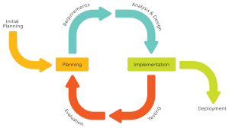

FIG.1: THE ITERATIVE SOFTWARE DEVELOPMENT MODEL.

3.6. PROPOSED SYSTEM ARCHITECTURE.

Handyman Haven is a website that would enable handy man services providers and their customers to meet. To allow for trust and a means for contact, the details of the handy men would be kept in a cloud server.s. Google Firebase is going to be used as the backend cloud server, as it allows for the utilization of things like authentication and cloud database storage.

The major aspects of the Handyman Haven.:

1. Registration: Handymen would have to register to have their details on the website. Currently, registration of customers is not seen to be necessary. After registration, their data is saved on a fire base database. The information will carry the name and firm name along with the location of the handyman shop. It would also carry a check box so that handymen can pick the fields they are can do.
2. Services: This section is where the customers will be able to search for the handymen in accordance to the field they are looking for.

3.7. System Design

System design is an essential stage in the software development process. It involves strategically planning a new system to either substitute or enhance the current system in place. The primary objective is to rectify any shortcomings of the previous systems, while aligning with the objectives established during the system analysis phase. During this stage, the system's architecture is outlined, and the interfaces are meticulously crafted to meet the specifications identified in the system analysis phase.

3.7 System Design Tools

In the development and dissemination of architectural diagrams, plans, and specifications for the proposed system, various tools are utilized to facilitate the design process. These tools, referred to as system design instruments, allow for the visual representation of system components and their interrelationships. There are diverse types of system design tools including:

Unified Modelling Language (UML)Unified Modeling Language (UML) is a widely accepted standard notation utilized for articulating the architecture and dynamics of systems through graphical representations. UML tools serve as instrumental resources for system design, facilitating the generation and modification of various UML diagrams, including state diagrams, sequence diagrams, and more

2. **Wireframing:** This is the process of creating low fidelity (low-fi) sketches of the user interface systems.

3. **System flowchart.** They are used mostly in combination with one another.

**3.8 System Design Tool: Unified Modelling Language (UML)**

The Unified Modelling Tool (UML) is a standardized notation, distinct from a programming language, utilized for the visualization, specification, construction, and documentation of software systems. It employs a series of diagrams composed of a variety of symbols and notations to represent the system's design. UML utilizes diagrams to depict the dynamic behavior of a system when it is operational. One such diagram is the use case diagram, which illustrates the interaction between the system under development and its components with the actors (users or other systems). This diagram provides a bird's-eye view of the functions performed by the system's components from the perspective of the actors, without delving into the specifics of implementation.. The draw a use case diagram, some notations (symbols) are used. They are:

1. **Actors**: Theses are entities that interact with the system. It includes human users, other internal or external applications, or hardware devices. They are usually represented using stick figures.

**2. Use Cases:** These are the things the system can do. It usually depicts the actions that the actors can perform using the system. It is usually represented by ovals.

**3. System Boundary:** This shows the scope of the system that has been modelled. Here, what is within the system and what is outside is defined clearly. It is usually depicted using a rectangular box that encapsulates all the use cases of the system.

**4. Relationships:** This shows the interactions between the actors and use cases. Some key types of relationships are

**Association Relationship** which represents the interaction between an actor and a use case. It is depicted by a line drawn to connect the actor to the use case.

**Include Relationship** which shows that a use case includes the functionality of another use case. It is depicted by a dashed arrow with the keyword ‘include’ drawn from a use case to the use case whose functionality is being included. Extend Relationship shows that under certain conditions, a use case can be extended by another use case. It is depicted by a dashed arrow with the keyword ‘extend’. The use case diagram for the proposed system is given below:

CHAPTER 4.

SYSTEM IMPLEMENTATION AND DOCUMENTATION.

* 1. Development Tools.

For the development of this software, Visual studio code (widely known as VS Code) was used as the code editor. It is an open-source code editor developed and maintained by Microsoft. For maintaining versions of the application, Git and GitHub were used as the version control system. Git is a version control system, while GitHub is a cloud storage for git repositories

* 1. . User Interface Design

In the realm of web development, simplicity and accessibility have become paramount (Johnson, 2020). Users today demand a seamless and hassle-free experience when accessing online services. Therefore, it is imperative to design platforms that prioritize ease of use and efficient information retrieval. Our front-end development adheres to these core principles of simplicity, efficiency, and user-friendliness.

A significant achievement in our project is the User Interface (UI) design. Extensive effort has been invested in creating an appealing and user-friendly UI that focuses on the most commonly used features of the platform. Users can easily navigate the platform, regardless of their technical proficiency. The UI design incorporates modern design principles combined with the latest technology (Johnson, 2020).

4.1.2 Search Functionality

The search functionality is at the heart of the platform's user experience. It has been meticulously designed to provide users with a simple yet powerful way to find handyman service providers. Users can select the exact service they require and specify their target areas to initiate a search. The search results are presented in a well-organized manner, providing all the necessary details about the handymen and their services. This approach ensures that users can make informed decisions quickly and effortlessly (Dave Evans, 2011).

Our primary focus was on enhancing the holistic user experience, aiming to ensure that the platform operates smoothly and without any hindrances for users. It is worth mentioning that users are not obligated to register accounts or partake in complex interactions.

Users can simply open the website, search for handyman services, and access all the information they need with ease (Johnson, 2020).

* 1. Node.js Back-End Development

4.2.1 Data Retrieval and Processing

After the successful deployment and verification of the front-end, we proceeded with the back-end development. This pivotal stage of our project was achieved through the utilization of Node.js, a sturdy platform for constructing back-end applications (Johnson, 2020). Node.js acts as the coding language for our website's back-end, offering a groundwork and gateway for our application.

* 1. Main Features.

The key features that make up the system are shown below:

1. Authentication: For the authentication, Google's firebase authentication was used to implement the functionality. If a user has an account, and the authentication is successful, the user’s details are fetched from the cloud database. (which in this case is Google’s cloud firestore). If the user is a lecturer, it goes to the lecturer’s dashboard; otherwise, it goes to the user’s dashboard. If the user does not have an account, they can also create an account. Any wrong type of input put into the text fields would be flagged as an error.

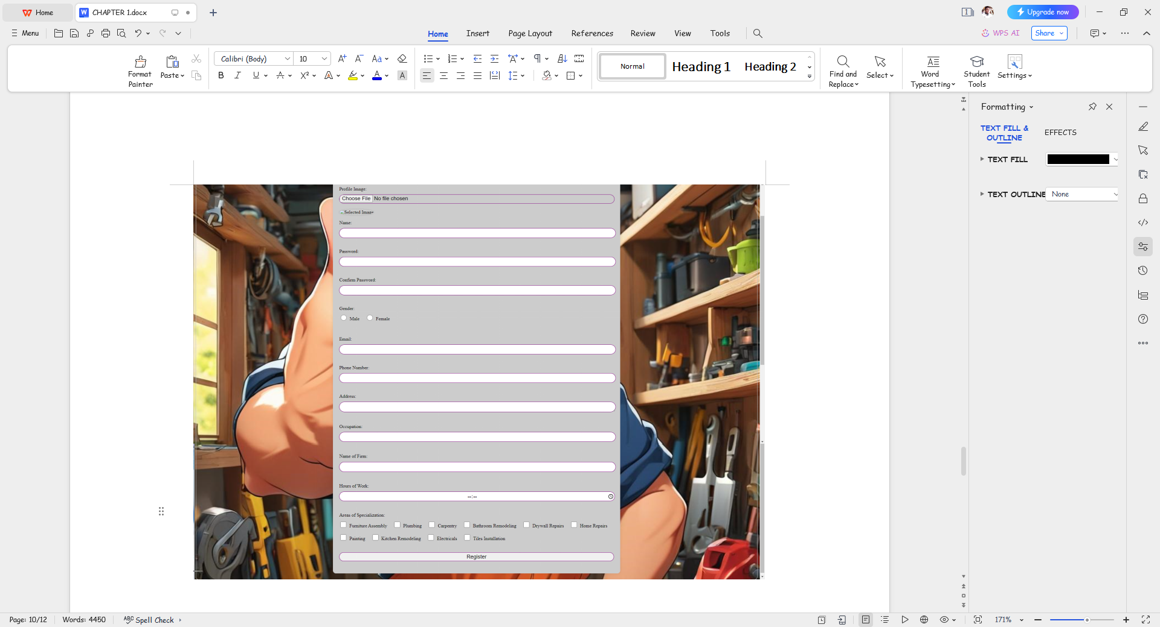

FIG. : THE REGISTRATION PAGE

1. The Home page : This is the first page that users and handy men. It was designed to be easy to understand. In case of any issues, a contact section was added.

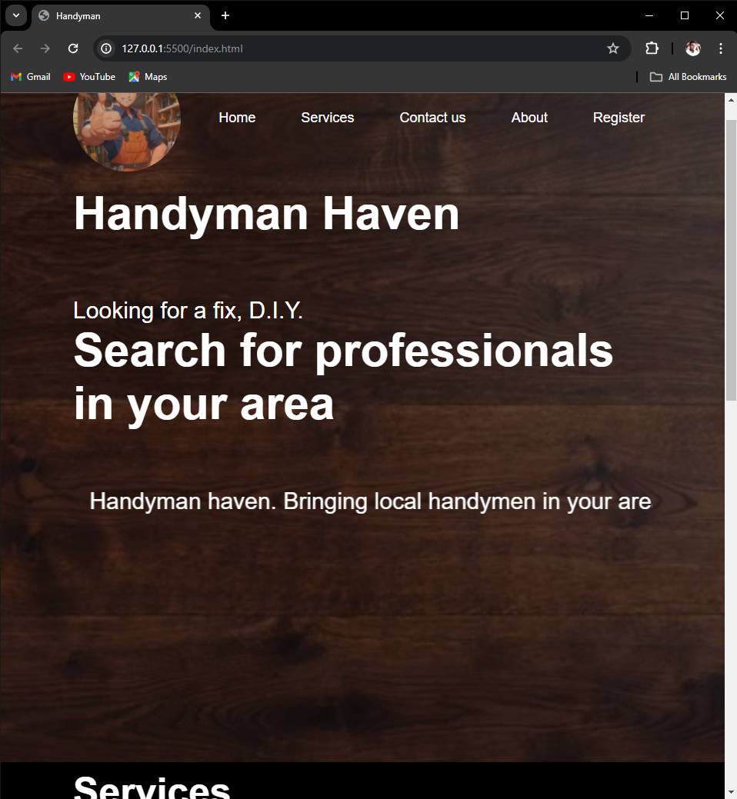

FIG.: THE HOME PAGE

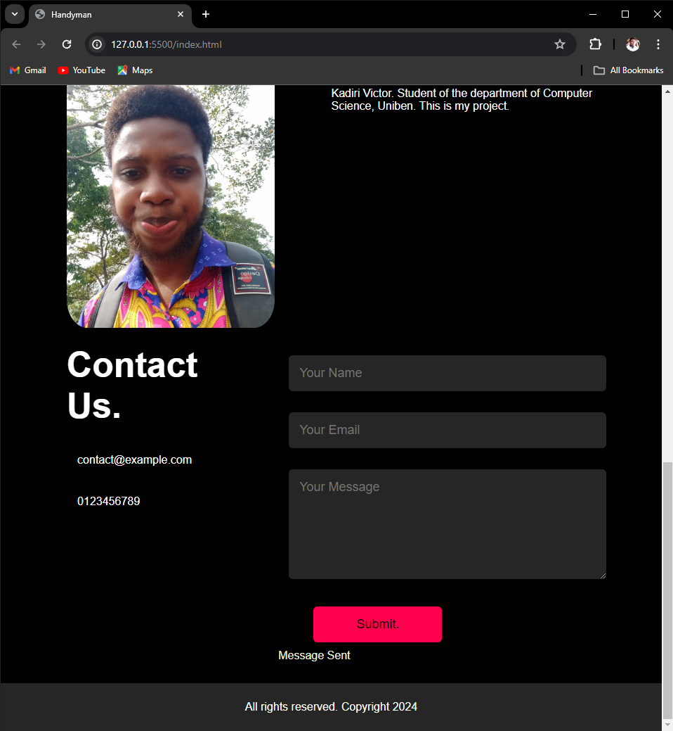

FIG ; THE CONTACTS SECTION.

1. The Services page.: This page has a few handyman services. Clicking on any of the services available will direct the user to a list of registered handy men for the field they chose. Clicking on the name would take you to a page showing the details of the selected handyman.

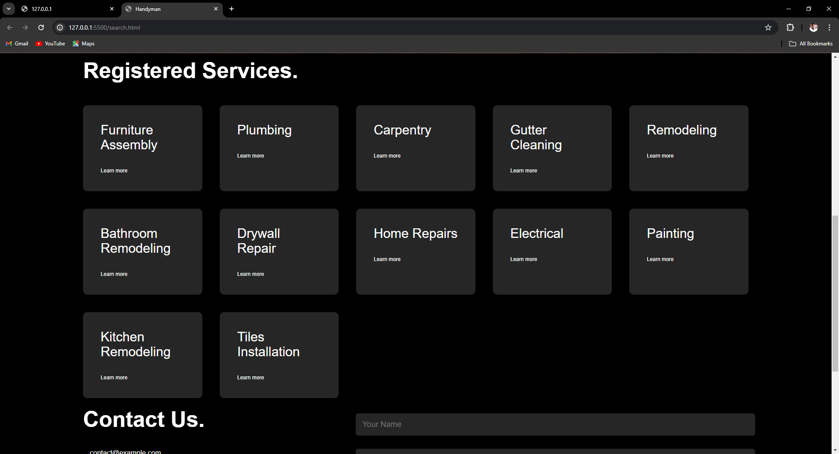

FIG .: THE SERVICES PAGE.

CHAPTER 5.

SUMMARY AND CONCLUSION.

**5.1 Project Evaluation**

Upon the successful creation of the Handymen platform "Handyman Haven", it is imperative to conduct a thorough assessment to measure its efficacy and acquire meaningful perspectives. This section will offer an intricate examination of the evaluation procedure and disclose the findings derived from the evaluation.

Chapter one introduced the challenges of the existing system and outlined the project's goals. Chapter two reviewed the history and evolution of Handymen services. Chapter three described the system model, design, architecture, and compared the current state with the proposed “Handyman Haven”. Chapter four detailed the development tools and system documentation. Finally, we have a summary and conclusion on the project topic

**5.1.1 User Feedback and Satisfaction**

User feedback serves as a fundamental pillar of our evaluation process. We greatly appreciate the contributions of both artisans and clientele who have engaged with our platform. Their firsthand experiences and perspectives offer priceless data for evaluating the platform's efficacy and pinpointing areas in need of enhancement.

Users have commended the platform's simplicity and accessibility. The absence of a complex registration process has been a significant advantage, making the platform approachable to a diverse range of users. This feedback aligns with the core objective of creating a user-friendly platform (Johnson, 2020).

Efficient data retrieval from Google Data Sheets has received praise from users. The lightning- fast access to handyman information has contributed to a sense of satisfaction among users. This efficient data retrieval has been a hallmark of the platform, ensuring quick and accurate results (Dave Evans, 2011).

﻿

The real-time capabilities of Nodejs have provided users with a dynamic and responsive experience. Users can trust that the information they access on the platform is current and up-to- date. Real-time updates and data synchronization have kept users engaged and informed

(Johnson, 2020),

﻿

**5.2 Achievements and Lessons Learned**

**5.2.1 Achievements**

Throughout the development and deployment of the Social Care Handymen platform, several notable achievements have been realized:

i. Simplicity and Accessibility: The platform's user-friendly interface and the absence of complex registration processes have made it widely appreciated by users. These features have contributed to the platform's approachability and ease of use (Patel et al., 2016).

ii. Efficient Data Retrieval: Leveraging Google Data Sheets for data storage and retrieval has resulted in lightning-fast access to handyman information. Users have consistently experienced quick and accurate results, enhancing their satisfaction (Dave Evans, 2011).

iii. Real-time Capabilities: The integration of Node.js has empowered the platform with real-time- capabilities. Users can rely on the platform for up-to-the-minute information and dynamic experiences. This has played a significant role in user retention and engagement (Johnson, 2020).

**5.2.2 Lessons Learned**

The journey of developing the Social Care Handymen platform has imparted valuable lessons:

.i. User Engagement: Continuous user engagement and feedback are essential. Seeking periodi user feedback is an ongoing process that leads to continuous improvement. It is crucial to remai receptive to user preferences and pain points (Ogundairo et al., 2020).

ii. Performance Optimization: Platform performance requires continuous monitoring and optimization. Even a seemingly simple platform benefits from regular performance checks and enhancements to ensure optimal user experiences (Johnson, 2020).

iii. Scalability: As the user base grows, scalability becomes a strategic challenge. Effective data storage and management must be planned to accommodate a growing number of users (Forsyth & Ponce, 2012).

iv. Rating and Review System: Incorporating a rating and review system would introduce accountability and trust. Users could rate services and provide feedback, aiding others in making informed choices. Additionally, it would enhance the platform's credibility (Ogundairo et al., 2020).

5.3 Future Directions

As we reflect on our achievements and lessons learned, several future directions and enhancements for the Handymen website become apparent:

i. Mobile Application Development: Developing mobile applications for both iOS and Android devices would expand the platform's reach and accessibility. Mobile apps offer a more user- friendly and tailored experience, aligning with current trends (Patel et al., 2016).

In conclusion, the Social Care Handymen platform has succeeded in providing a highly valuable and user-indulgent service. Through careful evaluation, we have identified strengths and areas for improvement, and we remain committed to enhancing the platform to better serve the needs of our users.

REFERENCES.

Ogunrinde, M. A., Olatunji, A. B. and Odeniyi, L. A. (2023). A Collaborative Service Provider Platform for Handyman Services, University of Ibadan Journal of Science and Logics in ICT Research (UIJSLICTR), Vol. 9 No. 1, pp. 115 – 130

ResumeCat Editorial Team (2022). 12 Handyman Skills: Definition and Examples Published September 2, 2022. <https://resumecat.com/skills/handyman>

Clyde, H. M., (2019), Real Wealth Without Risk: In 48 Hours, Break Free from the "Artificial Wealth Trap" ... ISBN 9781614484134.

Azene, F. T. (2014). Location Based Services for Low-End Mobile Phones. Thesis submitted to the Faculty of Geo-information Science and Earth Observation of the University of Twente.

Ajzen. I. (2018). The theory of planned behavior. Organizational Behavior and Human Decision Processes, 179-211.

Ricelumber.com.5 COMPELLING REASONS YOUR HANDYMAN BUSINESS NEEDS A WEBSITE NOW.

https://ricelumber.com/blogs/news/5-compelling-reasons-your-handyman-business-needs-a-website-now#:~:text=With%20a%20website%2C%20your%20handyman,office%2C%20your%20website%20never%20closes.

Johnson, J. (2020). "Laravel: Up and Running: A Framework for Building Modern PHP Apps" (2nd ed.). O'Reilly Media.

Ogundairo, J. A., Oladejo, S. O., & Oladejo, K. O. (2020). "The growth and challenges of the informal service sector: The case of handymen in Lagos, Nigeria." African Journal of Science, Technology, Innovation and Development, 12(1), 19-28.

Adigun, O., Eweoya, I., & Ajayi, O. (2019). "Examining the impacts of mobile phone

penetration on internet accessibility in Nigeria." Journal of Science and Technology

Policy Management, 10(3), 543-562.

Almeida, F., & Monteiro, J. (2017). Approaches and Principles for UX web experiences. International Journal of Information Technology and Web Engineering, 12(2), 49-64.

Rouse, Margaret (2019). "Internet of things (IoT)." IOT Agenda.

MAY BE USED LATER.

**For this project, we will be using the Software Development Life Cycle (SDLC).SDLC is a process that development teams use to minimize risk and ensure that software meets customer expectations throughout production and beyond.

**(FROM CHAPTER 2) In our case, we chose Node.js for the backend framework due to its high performance, scalability, and extensive developer community (Johnson, 2020). Node.js's asynchronous, event-driven architecture makes it ideal for real-time communication, a vital requirement for our platform.

Version control and continuous integration are managed using GitHub, which allows team members to collaborate, share code, and track changes efficiently (Johnson, 2020). This approach enhances project transparency and facilitates contributions from multiple team members. By carefully evaluating and selecting the right tools and frameworks, we have laid a

solid technological foundation for our platform, poised for scalability and adaptability,

THINGS TO ADD.

1. UML DIAGRAMS. (CHAPTER 3 AND 4)
2. IMAGES OF THE WEBSITE
3. CORRECT CHAPTER 2.